PROJECT REPORT

Title-
Predicting Compressive Strength of Concrete using IBM Watson AutoAI Experiment.

Submitted by-
Ishita Goel

INDEX

- Introduction
  - Objective
  - Purpose
- Literature Survey
  - Existing Problem
  - Proposed Solution
- Theoretical Analysis
  - Block Diagram
  - Hardware/Software Designing
- Experimental Investigations
- Flowchart
- Result
- Applications
- Conclusion
- Bibliography

- Introduction-

  - Overview-
Compressive strength of concrete is a major problem in civil engineering as compressive strength of concrete is tested by 28 day cylinder test results. Concrete is a great versatile material used in construction due to its good compressive strength, durability and low cost. Concrete great availability and low cost making it widely used in construction work therefore it is highly recommended to check the compressive strength of concrete one has to wait for 28 days test results to ensure quality control of processes due to which it is very time consuming and leads civil engineering industry require more time for the completion of project. In this modern era where human resources are way above high to satisfy any needs implemented advanced machine learning techniques which progressively simulate the characteristic of concrete materials and thus proposed an important research area through which strength of concrete can be determined by early age results.

In this model we use suitable machine learning algorithms to predict result and minimize errors through various metric evaluation techniques like mean square error(MSE), mean absolute error(MAE), root- mean-square error(RMSE) etc. It mainly uses two algo random forest and gradient booster to enhance accuracy of model.

  - Purpose-
Purpose of predicting compressive strength of concrete is to save 28 days test results time that will be inefficient for both purchaser as well as constructors. Machine learning techniques predict 28 days results in just seconds by analyzing previous data or results. It allows constructors to understand weakness of concrete material and based on that initiate destruction or construction process. In this time of competitive environment no corporate construction can bear to lose tender due to incompletion of projects on required time because of just one parameter that is ensuring quality of concrete. This model not only benefits purchaser but stakeholders also.

We focused on evaluating and analyzing performance of set of tree using ML techniques and algo for predicting compressive strength.
- Literature Survey-

  - Existing Problem-
Determining accurate concrete strength is a major civil engineering problem. Test results of 28-day concrete cylinder represent the characteristic strength of the concrete that has been prepared and cast to form the concrete work. It is important to wait 28 days to ensure the quality control of the process, although it is very time-consuming. There are several ancient methods to evaluate concrete strength like compression test on concrete cores, rebound hammer method, pull-out test method, ultrasonic pulse velocity method ,but none of these methods accurately evaluate concrete strength, provide reliable results as some develop cracks ,damage concrete and some might affected due to concrete cracks. So we have one option to test compression strength of concrete without even really testing on concrete that is machine learning techniques which analyze previous data to predict compression strength.

  - Proposed Solution-
An ability to predict the compressive strength of concrete early allows constructors to quickly understand the concrete's probable weaknesses and make a decision to manage a destruction process or continue with construction. Further, to the benefit of both user (and purchaser) and producer, reliably and rapidly predicting the results of a 28-day test would benefit all stakeholders as opposed to waiting the full, conventional, 28 days.

We are building a Machine Learning model to predict the compressive strength of concrete using IBM Watson AutoAl Machine Learning Service.

- Theoretical Analysis-

  - Block Diagram-

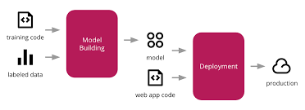

  - Hardware/Software Designing-
In this machine learning project model, the soul usage is of the software model, hence there is no special hardware involved in this project.

The web application created consists of the IBM Watson Machine Learning as the backend service and Node-RED for the development of the user interface.

AutoAI Experiment-
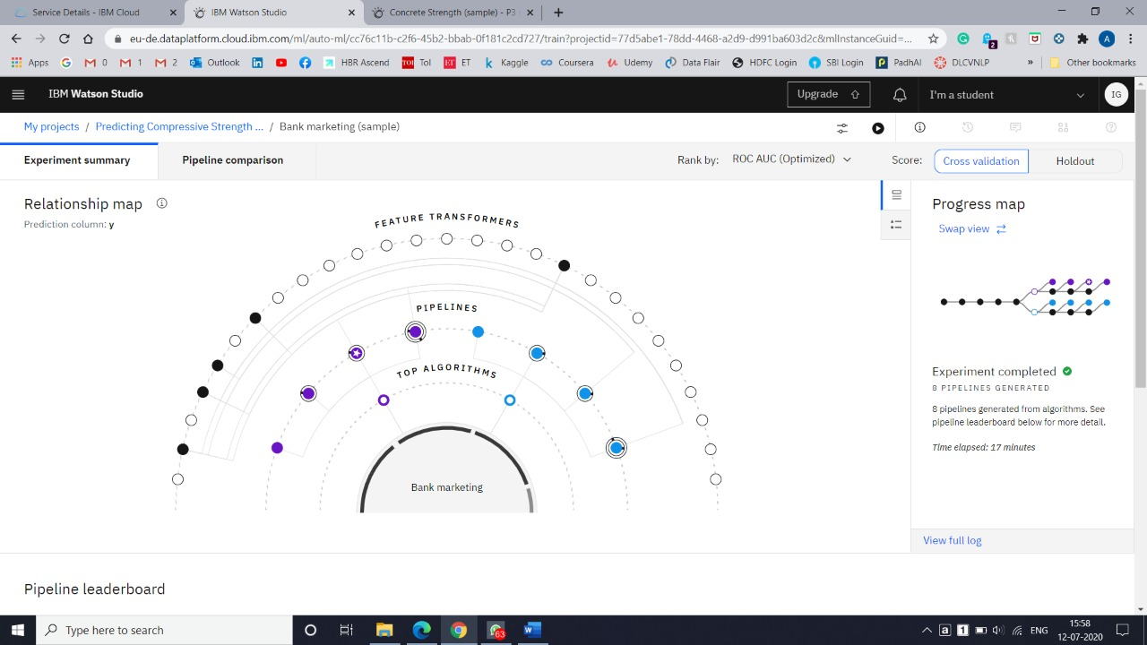
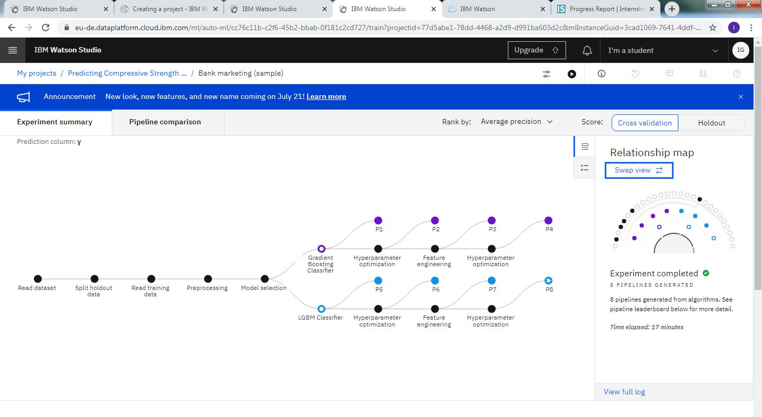

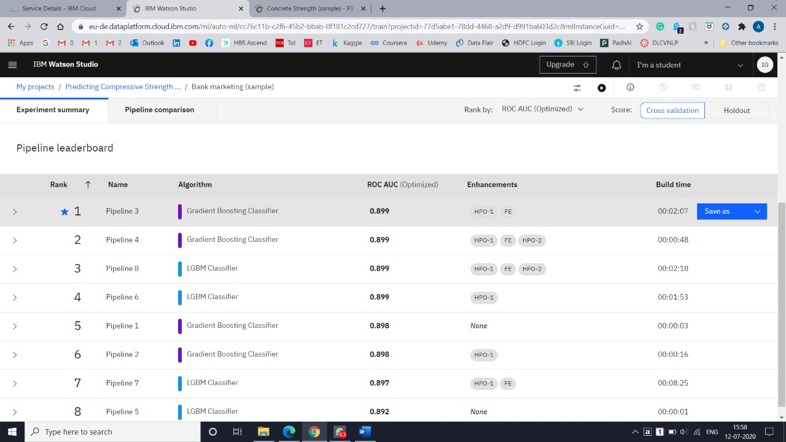
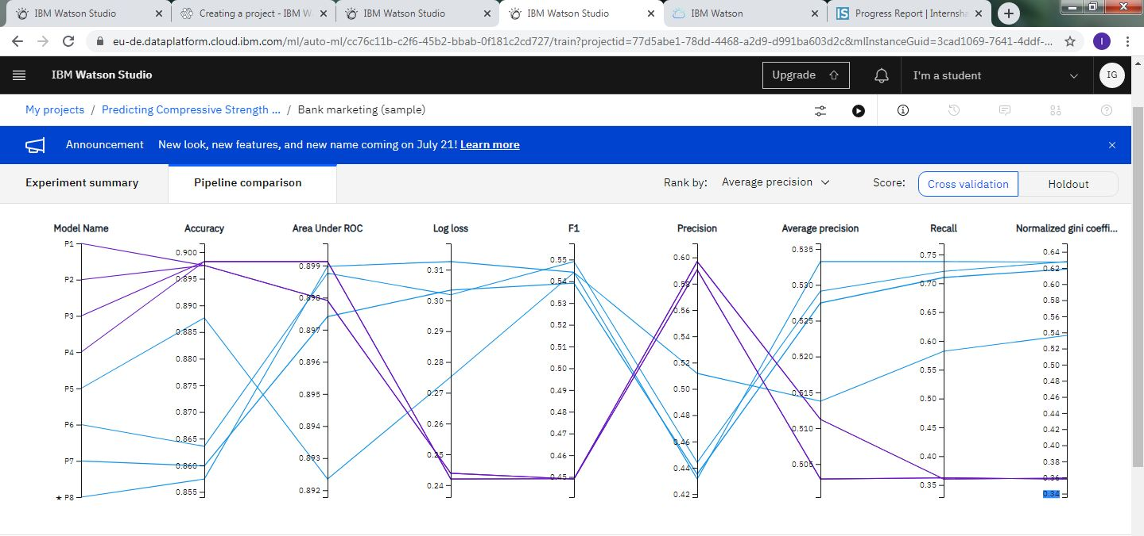

- Experimental Investigations-
Firstly, the data is collected from the given data set. Then a model is built on the IBM Watson studio machine learning to predict the life expectancy for the people of the country. For that, an account is to be created on the IBM Watson studio then a project is added with the auto AI option. Then the data set is uploaded and the best possible way to predict the life expectancy is chose. Finally, the model is executed and tested with the various data, factors and different circumstances.

Then a cloud foundry application is created from the Node-RED, and created a Node-RED flow. At last an API key is added with an ID and URL. And with the execution of the model the User Interface can be seen from the dashboard.

The data of the given dataset had to be updated with some the information as the available dataset had some missing information due to which the outcome was dropped from the data frame due to which the model was unable to learn from the missing values. The missing values were filled with the mean value of the respective feature for the particular country.

- Flowchart-

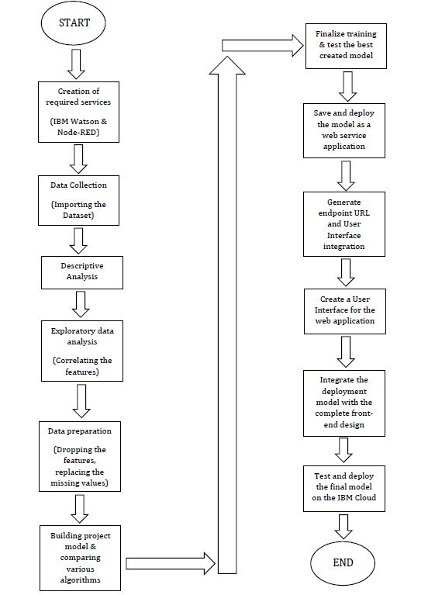

- Result-
The web application is created successfully with good and appropriate results.

The model is working properly as expected and fulfills all the given circumstances and it properly manages and processes all the factors provided and give away the required result.

The web application is available in the following link:
https://node-red-wqcxm.eu-gb.mybluemix.net/ui/#!/0?socketid=lXyaBn3H3oiekLEYAAAD

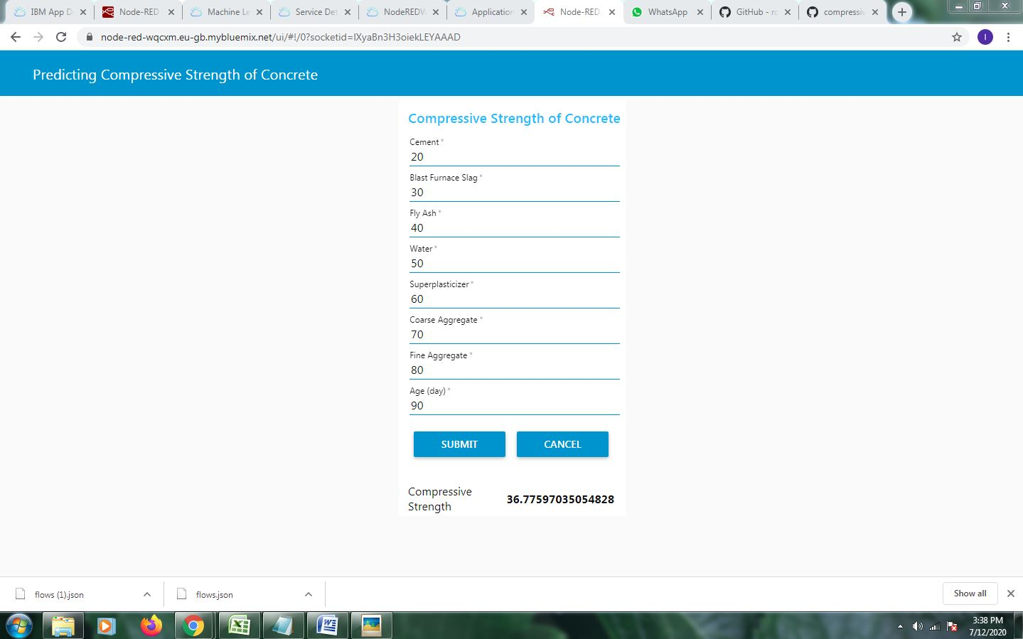

- Application-
Some applications of this project are-
- Material strength prediction.
- Determine weightage of mixture of construction ingredients.
- Minimizing collapse of the building.

- Conclusion-

The main purpose of the application is to build machine learning model to predict compressive strength of concrete using IBM Watson Auto Al Machine Learning service. The model is deployed on IBM cloud to get scoring end point which can be used as API in mobile app or web app building. We are deploying web app using Node-Red service.

The model prediction is then showcased on User Interface.

Construction companies use this model to predict strength of concrete and also helps in building higher strength concrete by determining weaknesses of concrete and check materials that are highly correlated with concrete material. Concrete can have cracks or void or irregular surface inside which decreases its age therefore machine learning techniques helps in determining those parameters so that any civil engineering deployment dont need repair before their age of destruction. Machine learning techniques not only solve real world problems but also effective in solving our day-to day tasks to make our life more better. This model not only saves time but beneficial for whole construction corporations.

- Bibliography-

- https://developer.ibm.com/tutorials/how-to-create-a-node-red-starter-application/

- https://github.com/SmartPracticeschool/llSPS-INT-1942-Predicting-Life-Expectancy-using-Machine-Learning?files=1

- https://my15.digitalexperience.ibm.com/b73a5759-c6a6-4033-ab6b-d9d4f9a6d65b/dxsites/151914d103d2-48fe-97d9-d21166848e65/

- https://www.youtube.com/watch?v=K7g4D4sdBEQ

- Compressive strength prediction using ML
ine-learning-4a531 b3c43f3

